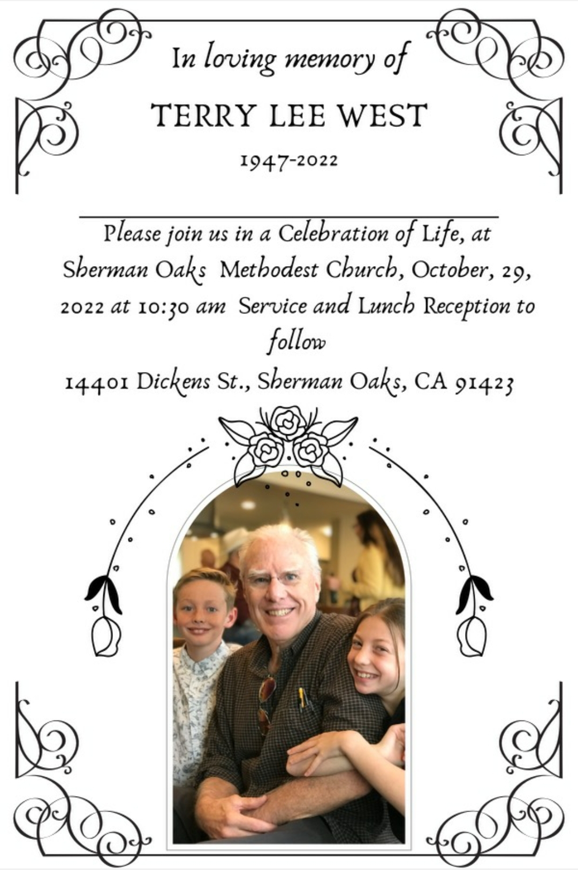

OCTOBER 29, 2022 † SAT † 10:30 AM
In Person & Livestream

Sherman Oaks United Methodist Church
14401 Dickens St. Sherman Oaks, CA 91423

The Rev. Garth C. Gilliam, Pastor
Officiant
THE ORDER OF SERVICE

PRELUDE “Amazing Grace” Jerry Lang II

WORDS OF GRACE & GREETING Rev. Garth Gilliam

HYMN “How Great Thou Art” Praise Team

PRAYER

SONG “Forever Young” Terrell Moran

OLD TESTAMENT SCRIPTURE Psalm 23 Kim Todd-Tullos

SONG “Blowing In The Wind” Nathan Kersey-Wilson
(Instrumental)

READING OF OBITUARY Phillip Johnson

FAMILY & FRIENDS REFLECTION

HYMN “Precious Lord” Jill Young

NEW TESTAMENT SCRIPTURE Stephen Heu
Epistle Reading: 2 Cor 4:16 – 5:1
Gospel Reading: John 14:1-4, 18-19, 25-27

WORDS OF COMFORT & HOPE Rev. Garth Gilliam

SONG “Because He Lives” Praise Team

COMMENDATION / BLESSING

CLOSING PRAYER

THE LORD’S PRAYER

BENEDICTION

CLOSING SONG “Don’t Think Twice, Its Alright” Nathan Kersey-Wilson
(Instrumental)

FILM TRIBUTE “Stone Café” Excerpt Stephen Heu

Following the service, the family invites all to a
lunch reception on the lower level of the church (Phillips Hall).
OBITUARY

Terry Lee West, 75, passed away on Oct. 18th, 2022. He was born on April 6th, 1947 to Mr. and Mrs. West in Santa Monica, California. After Terry graduated from high school, he went on to study at UCLA (Go bruins!). He started teaching at Van Nuys Junior High School as a history teacher, kickstarting a 30 year career. Terry met Judy West at The Morgan Theater in Santa Monica. Terry and Judy helped raise 2 children, Phillip and Randy.

In 2018, Terry retired and spent his time with his grand kids, Carter and Caeli. He spent hours gardening, dancing, reading the newspaper and playing with his grandkids.

In lieu of flowers, the family requests donations be made to St. Jude .Org, an organization that helps kids with cancer.

